***MY SQL ASSIGNMENT 4***

**Q1.Writeaquerytocalculatethetotalsales(Quantity*UnitPrice)foreach product.**

SELECTProductID,sum(Quantity*UnitPrice)as"totalsales"fromSales GROUP BY ProductID;

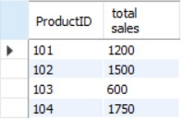

# Q2.Writeaquerytofindthetotalnumberofproductssoldineachregion.

SELECTRegion,count(ProductID)as"totalnumberofproductssold"fromSales GROUP BY Region;

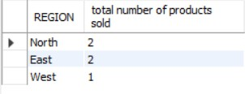

# Q3.Writeaquerytogettheaveragesalesamountperproduct.

SELECTProductID,avg(Quantity*UnitPrice)as"averagesalesamount"fromSales GROUP BY ProductID;

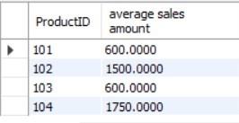

SELECTRegion,sum(Quantity*UnitPrice)as"totalsales"fromSales GROUP BY Region

HAVINGsum(Quantity*UnitPrice)>3000;



# Q5.Writeaquerytogetthemaximumquantitysoldforeachproduct.

SELECTProductID,max(quantity)as"maximumquantitysold"fromSales GROUP BY ProductID;

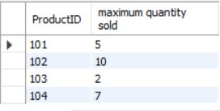

# Q6.Writeaquerytocalculatetheaveragequantityofproductssoldper region.

SELECTRegion,avg(quantity)as"averagequantityofproductssold"fromSales GROUP BY Region;

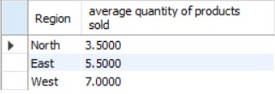

# than1000.

SELECTProductID,sum(quantity*UnitPrice)as"totalsalesamountofmorethan1000" from Sales

GROUPBYProductID

HAVINGsum(quantity*UnitPrice)>1000;

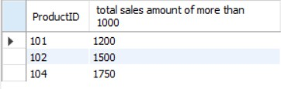

# Q8.Writeaquerytogetthetotalnumberofsales(rows)madeforeach customer.

SELECTCustomerID,count(Quantity)as"totalnumberofsales"fromSales GROUP BY CustomerID;

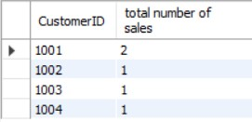

# Q9.Findtheproductsforwhichtheaveragequantitysoldislessthan 5.

SELECTProductID,avg(quantity)as"averagequantitysold"fromSales GROUP BY ProductID

HAVINGavg(quantity)<5;

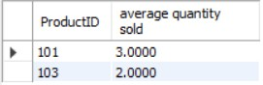

SELECTCustomerID,Region,sum(Quantity*UnitPrice)as"TotalSales"fromSales GROUP BY CustomerID, Region;

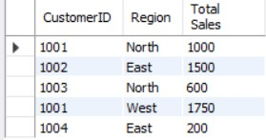

# Q11.Writeaquerytocalculatethetotalsalesforeachmonth.

SELECT EXTRACT(MONTHFROMSaleDate)asmonth,sum(Quantity*UnitPrice)as"Total Sales" from Sales

GROUP BY EXTRACT(MONTHFROMSaleDate);

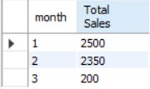

# Q12.Findtheregionswheretheaverageunitpriceismorethan200.

SELECTRegion,avg(UnitPrice)as"averageunitprice"fromSales GROUP BY Region

HAVINGavg(UnitPrice)>200;

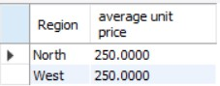

SELECTRegion,min(Quantity),max(Quantity)fromSalesGROUPBYRegion;

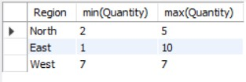

# /*Q14.Findthecustomerswhohavemademorethan2purchases.*/

SELECTCustomerID,count(ProductID)fromsales group by CustomerID

havingcount(ProductID)>1;



# Q15.Writeaquerytofindthetotalsalesforeachproductandfilteronly those products where the total sales exceed 1500.

SELECTProductID,sum(Quantity*UnitPrice)as"totalsales"fromSales GROUP BY ProductID

HAVINGsum(Quantity*UnitPrice)>1500;

